Record No: 0574
ELIZABETH GEALE

2ND wife of Sir Marcus Somerville.

Birth: abt 1805
Marriage 1: 10 Apr 1825, Sir Marcus Somerville MP
Marriage 2: 26 July 1841. Hugh 2nd Earl Fortescue, Lord Lt of Ireland
Death: 4 May 1896, 68 Brook Street London in her 92nd year

Notes: She became Countess of Fortescue when she married for the second time.
She was also the 2nd wife of Hugh Fortescue.
Irish Times 7 May 1896, death notice for Elizabeth, Countess of Fortescue.

Source: Somerville Index.
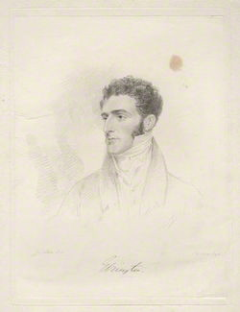
Hugh 2nd Earl Fortescue, Lord Lt. of Ireland
Source: National Portrait Gallery

